

**ISE 140 Project Report**

San Jose State University

Group No.-32

Team Members

Niyati Patel

Tousifur Rahman Khan

Samarth Bhargava

Daniel Everett

Contents

1.0 Introduction: 3

1.1 Background: 3

1.2 Problem Statement: 3

1.3 Objective: 3

2.0 Methods and Procedures: 4

2.1Forecasting: 4

Product 1 4

Product 2 4

Product 3 5

Product 4 5

Product 5 6

2.2 Additional Forecasting Methods used: 6

2.2.1 Autoregressive Integrated Moving Average (ARIMA) Model: 6

2.2.2 Drift Method: 7

3.0 Planning 7

Product 1 7

Product 2 8

Product 3 8

Product 4 9

Product 5 10

References 11

Appendices……………………………………………………………………………….............12

# **1.0 Introduction:**

Viking’s division is a subsidiary of AK Enterprise, that produces a variety of nutritional supplements as well as ancillary equipment. It focuses on 5 main products namely Product 1, 2, 3, 4 and 5, which are directly sold to whole sellers and various other distributors. Viking’s division has been in a demand for about 4 years. With the increase in time and market, the number of competitor has increased, the demand decreased and thus the company has displayed a very poor history of demand back orders. The company experienced loss in their profit mainly due to low cost containment and long production cycles. The company operated under similar conditions for years and thus no longer exists. For the company to gain back its position, our team have come up with this report where in, we have covered methods for forecasting, planning and scheduling to reduce the cycle time for the 5 main products. This goal was developed by using appropriate forecasting, planning and scheduling methods.

# **1.1 Background:**

The company was in demand as there were not many companies producing such nutritional products. As soon as their patent expired, many other companies jumped into the market with similar products. With an increase in time, the demand for these products increased. Depending on the type of product, the demand for all the 5 products varied. It was observed that, some of these products had a seasonal demand, whereas some had a steady one. Fluctuations were observed from week to week. However, a loss in profit had incurred and that is the reason why they decided to look into their system deeply.

# **1.2 Problem Statement:**

With consistent demand backordering, the company has not been able to meet their demands. The cost containment in the production facility too was very low. Because of maintaining high work and progress inventory, production cycles increased, because of which they started to manufacture improper production quantities. Forecasting had decreased which ultimately resulted in poor machine utilization, running inappropriate lot sizes and minimal use of scheduling methodology. This continued for several years and thus the company could not risk operating under such circumstances and continue to remain in business. Their profit started falling drastically.

# **1.3 Objective:**

The report is focused on establishing a proper method for forecasting the demands, planning the production based on bill of materials and capacity, and scheduling the production of the 5 products and reducing the cycle time for production. This is achieved by collecting cost information and production data on the manufacturing facility and thus includes performing time standards. Various methodologies for forecasting, planning and scheduling have been considered in order to meet these goals. The first step involves forecasting the demands for the 5 products by using the historical data given. Creating operational plan and sales is based on these forecasts. Aggregate planning is achieved for each product by analyzing the data and thus the cheapest aggregate plan is used to calculate materials requirement planning.

# **2.0 Methods and Procedures**:

## **2.1 Forecasting**:

Forecasting is the first step involved in planning the manufacturing process. Historical data were provided from week 1 to week 20. The Mean Absolute Deviation (MAD) tolerance should not exceed 10 while considering 10 most recent weeks. The graph of time horizon which is an independent variable (X) was plotted against the actual demands, which were the dependent variables (Y).

### **2.1.1 Product 1**

The graph of actual demand vs time horizon was plotted, and it was observed that the demand was stable. The demand fluctuated between 120 to 160 units. No seasonality or trend was observed. And thus, the weighted moving average method was selected. The forecast for week 21 to week 25 remains same as no actual demand was provided. The absolute error was calculated, and the resulting MAD value observed was 9.6 ­­­, which was within the MAD tolerance limit and thus, this model was accepted. The forecasts observed were as follows:

21st week-147.133;

22nd week-147.444;

23rd week-147.3837;

24th week-146.9398;

25th week-146.9889.

### **2.1.2 Product 2**

The 2nd product displayed a seasonal demand cycle with no trend which was found out after plotting a graph of actual demand versus time horizon. It was observed that there was a seasonal pattern where in after 9 weeks, the 10th demand data was very close to the first week. This showed that a 9 weeks seasonal cycle was followed. Using this model, seasonal indices were built. Forecasts for week 11-20 were carried out to check the validity of this model. MAD value was then calculated. It came out to be 2.64 which is within the tolerance limit and thus we can conclude that this model validates the next 5weeks forecasts. The forecasts observed were as follows:

21st week- 180.5461638;

22nd week- 202.8608583;

23rd week- 218.0754226;

24th week- 207.9323797;

25th week- 172.4317295.

### **2.1.3 Product 3**

Based on the graph, it was observed that product 3 exhibit seasonality with an increasing trend. A total of four seasons were noticed with the increase in demands. The forecasting technique applied is exponential smoothing with seasonality and trend. The MAD was calculated for the last 10 weeks (11-20) which is observed to be 2.42 which was below 10. And thus, this method validated the given data set. The forecasts observed were as follows:

21st week-129.681968;

22nd week-129.681968;

23rd week-91.64542334;

24th week-78.03899314;

25th week-136.6697941.

### **2.1.4 Product 4**

A linear trend was observed for product 4.  As a result, linear regression was selected for obtaining forecasts. Where in Time Horizon is an independent variable(X) and the product is the dependent variable(Y). Linear regression was conducted using Excel. Using the Equation Y= β0+β1(X) where, β0 is the intercept and β1 is the slope, forecasts were developed. Mean Absolute Deviation (MAD) was calculated to check the validity of the model. The MAD value of 0.853 was obtained. The forecasting model was accepted since the MAD value obtained was within the tolerance limit. The forecasts observed were as follows:

21st week-82.31578947;

22nd week-85.4887218;

23rd week-88.66165414;

24th week-91.83458647;

25th week-95.0075188.

### **2.1.5 Product 5**

A graph of actual demand values versus time horizon was plotted to identify the most suitable Forecasting method. Neither an increasing nor a decreasing trend was observed: it was observed that the peaks were followed by valleys which cancelled them out. Based on this observation, exponential smoothing method was selected. As the actual demand for the week 21 to week 25 wasn’t provided, Naïve method was used to obtain the forecast. The absolute error for week 11 to week 20 was determined. The MAD value was thus found out to be 8.56 for the weeks 11 to week 20 which was less than 10 and thus this model validates the given data sets. The forecasts observed were as follows:

21st week- 44.04;

22nd week- 44.04;

23rd week- 44.04;

24th week- 44.04;

25th week- 44.04.

## 2.2 Additional Forecasting Methods used:

### 2.2.1 Autoregressive Integrated Moving Average (ARIMA) Model:

An Autoregressive Integrated Moving Average (ARIMA) Model is a generalization of an Autoregressive Moving Average Model (ARMA) mainly used in time series analysis. This method is used in predicting forecasts. In ARIMA, different terms hold a different meaning, namely:

AR refers to the use of dependent relationship between number of lagged observation and an observation; MA indicates that usage of a dependency between an observation and the residual error applied to lagged observations; I indicates the data values being replaced by the difference of their values and previous values. All these features make the model fit the data as much as possible.

parameters (p, d and q) are used to represent Non-seasonal ARIMAS, (p, d, q) (P, D, Q) m indicates seasonal ARIMA.

ARIMA can be represented by the equation:

Xt= μ + (β1 * (Zt-1 - μ)) + (β2 * (Zt-2 - μ)) + εt

By using ARIMA for the first product, we carried out the forecast for the last 10 weeks from which the MAD was calculated. The observed MAD value was 9.58 i.e. <10 and thus we can conclude that this method suits the data set provided.

### 2.2.2 Drift Method:

Another method which can be applied to the data set is the Drift Method. It is an alternative method to naïve method which allows the forecasts to increase or decrease, this change is termed as drift and referred to the average change that occurs in the data. It is represented as



## 3.0 Planning:

An activity that produces the production process for an aggregate plan is called is called aggregate planning. It involves giving in advance to the management, the quantity of materials, other resources that are required, so that the total cost of operations is minimum. Outsourcing, sub-contracting, overtime, number of laborers hired and fired, and the inventory needed to be held on hand and backlogged over each period is decided from aggregate planning.

### 3.1 Product 1

|  |  |  |  |  |  |  |
| --- | --- | --- | --- | --- | --- | --- |
| Period | 1 | 2 | 3 | 4 | 5 | Total |
| Beginning Inventory | 0 | 0 | 0 | 0 | 0 |  |
| Production Needed | 147 | 147 | 147 | 147 | 147 | 735 |
| Demand | 147 | 147 | 147 | 147 | 147 | 735 |
| Workers Needed | 5 | 5 | 5 | 5 | 5 | 25 |
| Workers Available | 10 | 5 | 5 | 5 | 5 |  |
| Workers Hired | 0 | 0 | 0 | 0 | 0 |  |
| Workers Fired | 5 | 0 | 0 | 0 | 0 | 5 |
| End Inventory | 0 | 0 | 0 | 0 | 0 | 0 |
| Backlog | 0 | 0 | 0 | 0 | 0 | 0 |
| Worker Production Capacity | 150 | 150 | 150 | 150 | 150 |  |
| Undertime | 3 | 3 | 3 | 3 | 3 | 15 |
| Average Inventory | 0 | 0 | 0 | 0 | 0 | 0 |

|  |  |
| --- | --- |
| **Costs** |  |
| Regular time costs/unit | $73,500 |
| Undertime costs/ min | $45 |
| Inventory holding cost | 0 |
| Hiring cost | 0 |
| Layoff cost | $100,000 |
| Backorder cost | 0 |
| Total cost | $173,545 |

By using the forecasting for week 21-25 for product 1, a level and a chase plan was drawn out. The cost for both production plans came out to be $173,543,In which no difference was observed. This shows that level plan is the best plan to go ahead with.

Table 1. Aggregate planning for Product 1

### 3.2 Product 2

After calculating the cost using chase and level production planning, it was observed that the total cost of level plan was lesser as compared to the chase plan, which would save $63606.2. Therefore, it is recommended to use level plan

|  |  |  |  |  |  |  |
| --- | --- | --- | --- | --- | --- | --- |
| Period | 1 | 2 | 3 | 4 | 5 | Total |
| Beginning Inventory | 0 | 15.6 | 9.2 | 0 | 0 |  |
| Production Needed | 196.6 | 196.6 | 196.6 | 196.6 | 196.6 | 983 |
| Demand | 181 | 203 | 218 | 208 | 173 | 983 |
| Workers Needed | 7 | 7 | 7 | 7 | 7 | 35 |
| Workers Available | 10 | 7 | 7 | 7 | 7 |  |
| Workers Hired | 0 | 0 | 0 | 0 | 0 |  |
| Workers Fired | 3 | 0 | 0 | 0 | 0 | 3 |
| End Inventory | 15.6 | 9.2 | -12.2 | -11.4 | 23.6 | 24.8 |
| Backlog | 0 | 0 | -12.2 | -11.4 | 0 | -23.6 |
| Worker Production Capacity | 210 | 210 | 210 | 210 | 210 |  |
| Undertime | 13.4 | 13.4 | 13.4 | 13.4 | 13.4 | 67 |
| Average Inventory | 7.8 | 12.4 | 1.5 | 5.7 | 11.8 | 39.2 |
|  |  |  |  |  |  |  |

Table 2. Aggregate planning for Product 2

|  |  |
| --- | --- |
| **Cost Calculations:** |  |
| Regular Cost | 78640 |
| Layoff Cost | 60000 |
| Backlog Cost | 424.8 |
| Undertime cost | 16080 |
| Holding cost | $470.40 |
| Total cost | 155144.8 |

### 3.3 Product 3

To estimate the total cost of production plan for week 21 to week 25, a level and chase plan were developed. The level plan included an ending inventory of 60 units in the last period which results in high inventory holding cost. The chase plan, at the end of period 25 has 0 units in inventory. As the chase plan has higher laying off and hiring cost, we go ahead with level plan as its cost of implementation is lower than chase.

Table 3. Aggregate planning for Product 3

|  |  |  |  |  |  |  |
| --- | --- | --- | --- | --- | --- | --- |
| PERIOD | 1 | 2 | 3 | 4 | 5 | TOTAL |
| Beginning Inventory | 0 | -10 | 7 | 35 | 77 |  |
| Production | 108 | 108 | 108 | 108 | 108 | 540 |
| Demand | 130 | 103 | 92 | 78 | 137 | 540 |
| Workers Available | 10 | 4 | 4 | 4 | 4 |  |
| Workers Needed | 4 | 4 | 4 | 4 | 4 | 20 |
| Workers Hiried | 0 | 0 | 0 | 0 | 0 | 0 |
| Workers fired | 6 | 0 | 0 | 0 | 0 | 6 |
| Units required | 108 | 118 | 101 | 73 | 31 | 431 |
| Units Produced | 120 | 120 | 120 | 120 | 120 | 600 |
| Undertime | 0 | 0 | 0 | 0 | 0 | 0 |
| End Inventory | -10 | 7 | 35 | 77 | 60 |  |
| Backorder | 10 | 0 | 0 | 0 | 0 | 10 |
| Average Inventory | -5 | -1.5 | 21 | 56 | 68.5 | 139 |

|  |  |
| --- | --- |
| **COST CALCULATIONS** |  |
| Hiring cost | 0 |
| Layoff cost | $120,000 |
| Inventory holding cost | $1,598.50 |
| Back order cost | $100 |
| Regulartime cost | $15,000 |
| Undertime cost | 0 |
| Total cost | 136698.5 |

### 3.4 Product 4

From the forecast gathered it can be seen that the level plan incurs less cost compared to chase plan. Level Plan includes 3 workers every week and thus 7 workers were fired. The worker production capacity which means that there will always exist an under time cost per unit of 1. The choosing criteria between two plans are inventory holding cost and undertime and thus level plan is recommended.

Table 4. Aggregate planning for Product 4

|  |  |  |  |  |  |  |  |  |
| --- | --- | --- | --- | --- | --- | --- | --- | --- |
|  | Week 1 | Week 2 | Week 3 | Week 4 | Week 5 | Total | | Cost |
| Beginning Inv: | 0 | 6 | 9 | 9 | 6 | 30 |  |  |
| Demand: | 83 | 86 | 89 | 92 | 95 | 445 |  |  |
| Production: | 89 | 89 | 89 | 89 | 89 | 445 |  | 66750 |
| Worker Needed: | 3 | 3 | 3 | 3 | 3 | 15 |  |  |
| Worker Available: | 10 | 3 | 3 | 3 | 3 | 22 |  |  |
| Worker Hired: | 0 | 0 | 0 | 0 | 0 | 0 |  |  |
| Worker Laidoff: | 7 | 0 | 0 | 0 | 0 | 0 |  | 140000 |
| End Inv: | 6 | 9 | 9 | 6 | 0 | 30 |  |  |
| Backlog: | 0 | 0 | 0 | 0 | 0 | 0 |  | 0 |
| Avg Inv: | 3 | 7.5 | 9 | 7.5 | 3 | 30 |  | 600 |
| worker production capacity | 90 | 90 | 90 | 90 | 90 | 450 |  |  |
| Undertime Cost per unit: | 1 | 1 | 1 | 1 | 1 | 5 |  | 1200 |
|  |  |  |  |  |  |  | **total cost=** | **208550** |

### 3.5 Product 5

The level and chase plan were determined to estimate the total cost of production plan for weeks 21 to weeks 25. Product 5 doesn’t hold an ending inventory and thus its holding cost will be 0, therefore, we go ahead with level plan.

Table 5. Aggregate planning for Product 5

|  |  |  |  |  |  |  |  |  |
| --- | --- | --- | --- | --- | --- | --- | --- | --- |
|  | Week 1 | Week 2 | Week 3 | Week 4 | Week 5 | Total | | Cost |
| Beginning Inv: | 0 | 0 | 0 | 0 | 0 | 0 |  |  |
| Production: | 45 | 45 | 45 | 45 | 45 | 225 |  | 45000 |
| Demand: | 45 | 45 | 45 | 45 | 45 | 225 |  |  |
| Worker Needed: | 2 | 2 | 2 | 2 | 2 | 10 |  |  |
| Worker Available: | 10 | 2 | 2 | 2 | 2 | 18 |  |  |
| Worker Hired: | 0 | 0 | 0 | 0 | 0 | 0 |  |  |
| Worker Laidoff: | 8 | 0 | 0 | 0 | 0 | 8 |  | 160000 |
| End Inv: | 0 | 0 | 0 | 0 | 0 | 0 |  |  |
| Backlog: | 0 | 0 | 0 | 0 | 0 | 0 |  |  |
| Avg Inv: | 0 | 0 | 0 | 0 | 0 | 0 |  |  |
| Undertime Cost per unit: | 15 | 15 | 15 | 15 | 15 | 75 |  | 18000 |
|  |  |  |  |  |  |  | **total cost=** | **223000** |

# 

# **References:**

* Maisondieu, C., Roth, J. C., Forest, B., Breivik, O., & Pavec, M. (2010, January). Methods for Improvement of Drift Forecast Models. Retrieved December, 2016, from <https://www.researchgate.net/publication/233918949_Methods_for_Improvement_of_Drift_Forecast_Models>
* <https://machinelearningmastery.com/arima-for-time-series-forecasting-with-python/>
* https://en.wikipedia.org/wiki/Autoregressive_integrated_moving_average

APPENDICES:

Graphs for forecasting:

**Figure 1**. Demand for Product 1(5 MWMA)

|  |  |  |  |  |  |  |  |  |  |  |  |
| --- | --- | --- | --- | --- | --- | --- | --- | --- | --- | --- | --- |
|  |  |  |  |  |  | 25 | 44.40 | -0.36 | 44.04 |  |  |

**Figure 2**. Demand for Product 2(SEASONAL CYCLE WITHOUT TREND)

**Figure 3**. Demand for Product 3(SEASONAL INDEX WITH TREND)

**Figure 4**. Demand for Product 4(Linear Regression)

**Figure 5**. Demand for Product 5(Exponential smoothning)

**Product 1 Planning:**

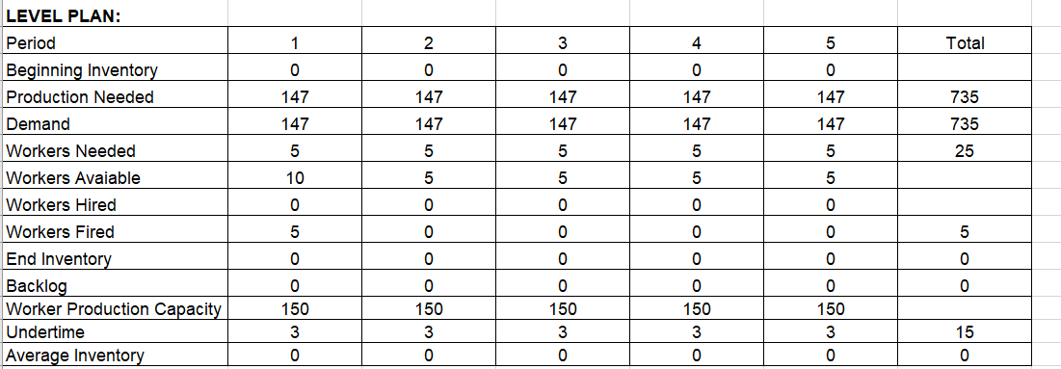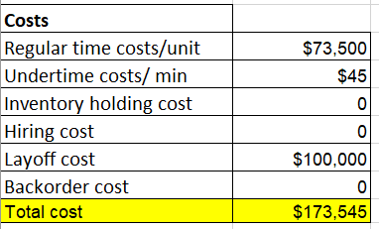Since forecast for week 20-25 is same. Chase plan is same as Level Plan.

**Product 2 Planning:**

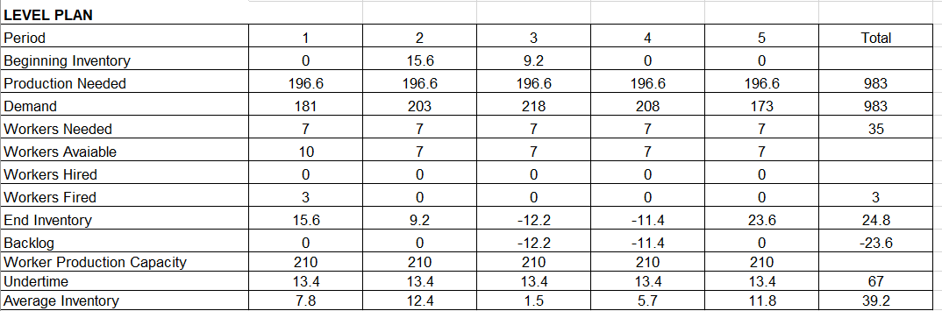

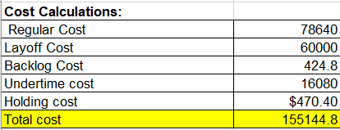

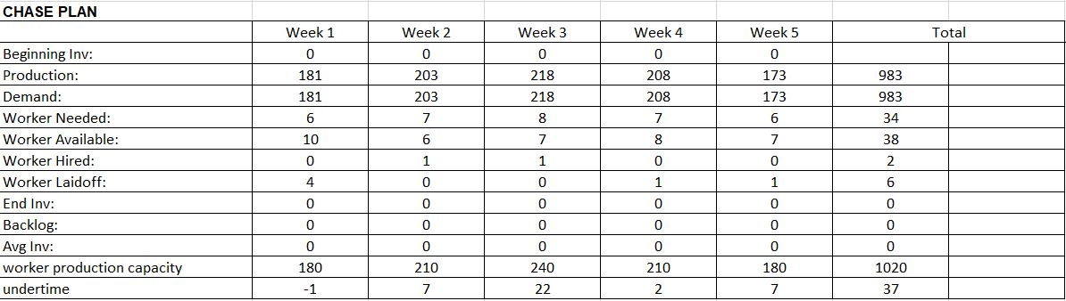

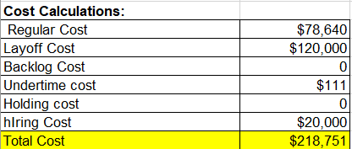

**Product 3 Planning:**

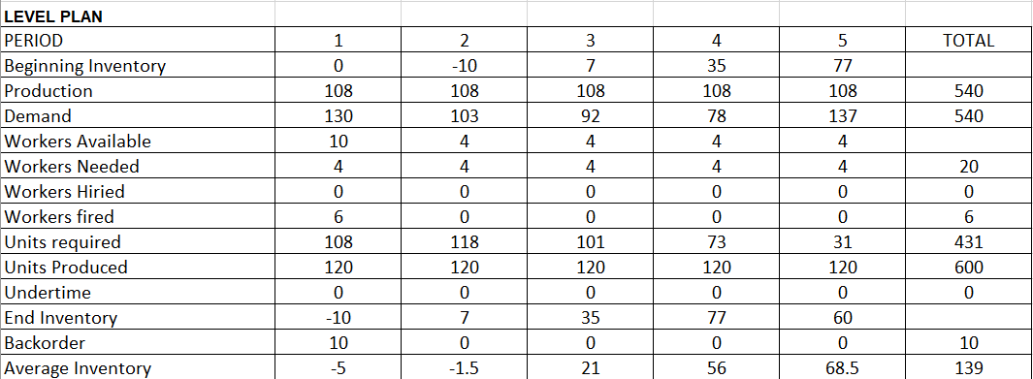

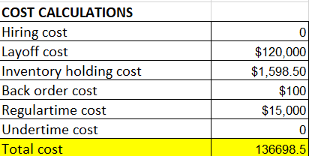

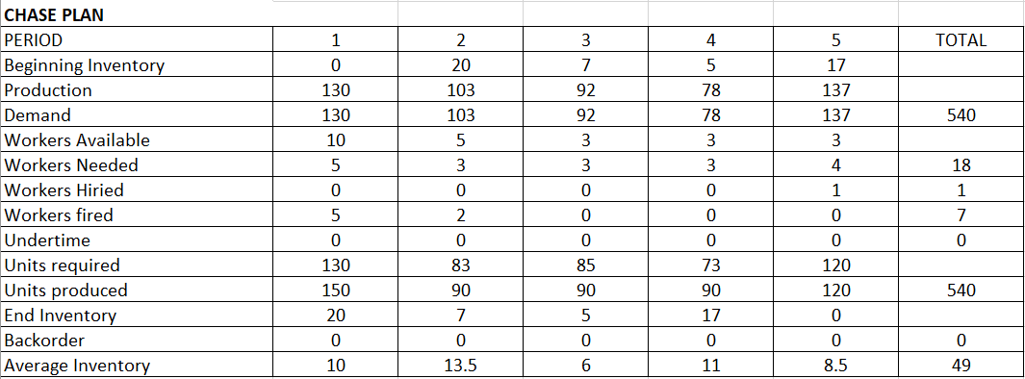

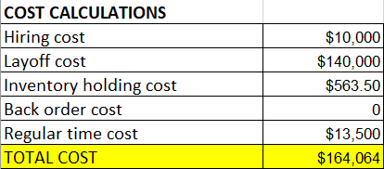

**Product 4 Planning:**

**LEVEL PLAN**

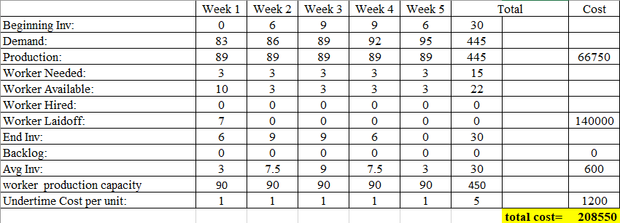

**COST CALCULATIONS**

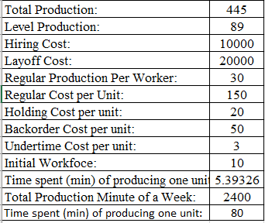

**CHASE PLAN**

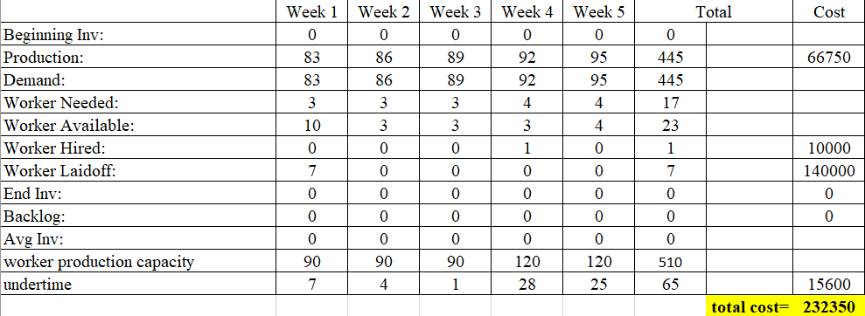

**COST CALCULATIONS**

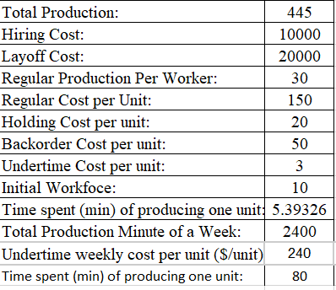

**Product 5 Planning:**

**LEVEL PLAN**

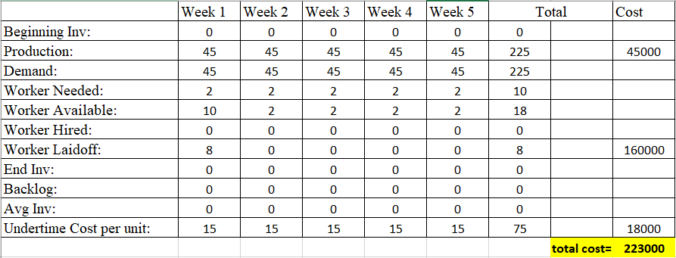

**COST CALCULATIONS**

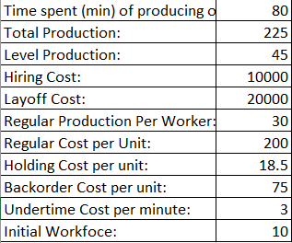 **There is no need for the chase plan so we move forward with the Level plan.**